**East West University**

**Department of CSE**

**Lab Report 01**

**CSE 453**

**Wireless Networking**

**Submitted To:**

Md. Mahir Ashhab

Lecturer

Department of Computer Science and Engineering

**Submitted By:**

Adri Saha

ID: 2019-1-60-024

Submission Date: 04 August 2022

Planning Terrestrial Radio Networks

(1st Part)

1. **How is the coverage in Kista area according to your simulation results? What is the received signal level in Kista?**

**Ans:** As required receiver threshold for good reception is 200μV. We set the threshold for Kista receiver 200μV. In our network, there are 2 receivers: Kista and Arlanda Airport. For receiver we set the threshold 200 μV according to the manual. We know, if received value is more than threshold value, coverage will be good.

**Figure 1**: Setting up threshold value

Then we found out, the received signal level for kista, Rx,

**Figure 2:** Showing received signal in Kista area

Here we can see Rx level from Nacka transmitter to Kista = 243.45 μV which is greater than threshold 200 μV. From figure 2, we also see the dotted line which presents the better coverage across Nacka to Kista. So, we can say according to my simulation result, the coverage area for receiver Kista area is good.

1. **What is the received signal level in Arlanda? Can you listen to the P4 radio at Arlanda airport?**

**Ans:** The received signal level in Arlanda is 91.93 μV according to my simulation.

**Figure 3:** Showing received signal in Arlanda airport area

From figure 3, we observe the red straight line which represents very poor coverage for Nacka to Arlanda. Also, we know, if received level value is more than threshold value receiver can listen the P4 radio. We set threshold value 200 μV for each receiver.

**Figure 4**: Setting up threshold value for Arlanda Airport

So, we see received signal for Arlanda receiver is 91.93 μV which is less than threshold value 200 μV. So, I can’t listen P4 radio at Arlanda airport.

1. **What is the reception limit in kilometers approximately? To find the approximate coverage radius, you can drag your mouse across the screen to make a line segment. Then you can read out the length of the segment in the information bar at the bottom of the screen.**

**Ans:** From simulation, we can observe reception limit in kilometers approximately 30.148 Km. To find the approximate coverage radius, I drag my mouse across the screen to make a line segment and found out the result below.

**Figure 5**: Showing reception limit in kilometers

1. **Briefly explain your solution method and results.**

**Ans:** My solution method and results are given below:

* First, I opened the radio lab and clicked on file. Then clicked on new network to create new network.
* Then opened default map.
* Clicked on new picture where draw mode is grayscale slope. Then clicked on draw.
* Go to file and then network properties: and make system1 to transmitter and system 2 to receiver.
* Kept transmitter’s transmit power 75 dBm. Keep the antenna type omni.ant. Antenna gain 2dBi. Antenna height: 250 meters.
* Then changed the receiver threshold at 200 μV. Make antenna gain 2dBi. And antenna height 1m.
* Then went to unit properties. Make a unit Nacka Transmitter and enter LAT LON or QRA and put the coordinates given on manual. N59º 17’ 45’’, E18º 10’33’’.
* Made another unit Kista receiver and enter LAT LON or QRA and put the coordinates given on manual. N59º 24’16’’, E17º 56’57’’.
* Made another unit Arlanda airport receiver and enter LAT LON or QRA and put the coordinates given on manual. N59º 24’16’’,
* Then went to network properties and created a network named SR p4. On SR p4 network marked 3 list of units. Nacka transmitter and set the system as transmitter from drop down box.
* On the same way, check kista and arlanda airport and set their system as receiver.
* Then made land cover disable and again go to network properties.
* Selected network SR p4. And change the parameters. Set frequency 103 MHz. Make polarization vertical, mode of variability Broadcast. Additional loss forest which is 30%. Surface refractivity 301, ground conductivity 0.02 (s/m). And clicked on ok.

**Figure 6:** Setting up parameters for network SR p4

**Figure 7**: Setting network system for transmitter and receiver

* Went to tools and radio coverage. Clicked on single polar radio coverage. Then set some parameters according to the manual.
* EIRP (radial range) maximum 50. Link direction Centre Tx - Mobile Rx. Plot: fill area. Threshold from 200 μV. And draw.
* Finally, we will see all the networks accordingly.
* Click on view-show network-all.
* Drawing is complete. Go to radio link and check the simulations results.
* By view we can see details, range, and distribution.

Here are some results are given,

**Results:**

**Nacka to Kista receiver:**

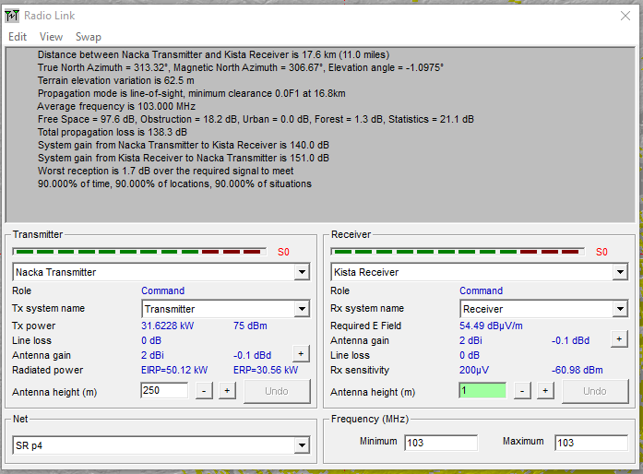

**Figure 8:** Nacka to Kista details

We find here details of the map like distance between Nacka to Kista is 17.6 Km. Then we see propagation loss, system gain etc.

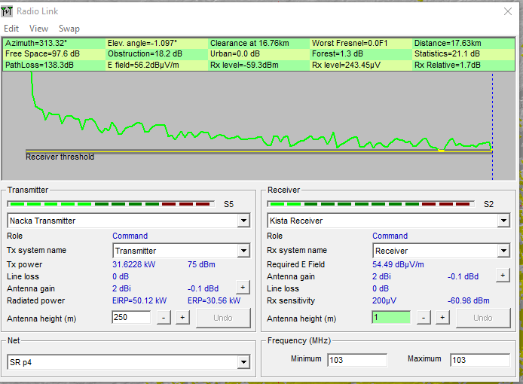

**Figure 9:** Nacka to Kista range

We see, there are no failure in signal distribution from Nacka to Arlanda airport. The positive green line on the graph shows the success rate of transmission.

**Figure 10:** Nacka to Kista distribution

From distribution, we see for the threshold signal, receiving signal is successfully distributed from Nacka to Kista receiver.

**Nacka to Arlanda airport receiver:**

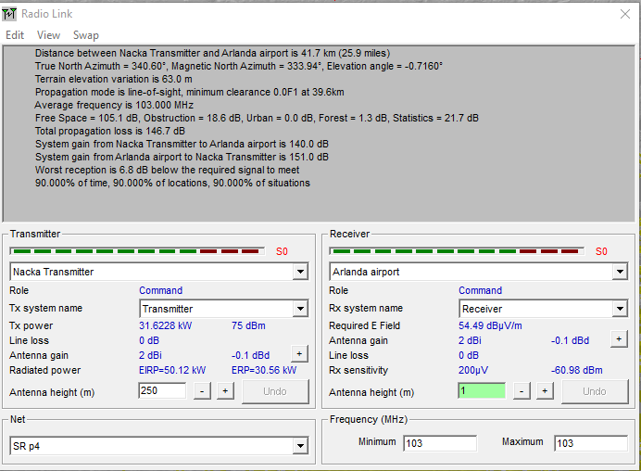

**Figure 11**: Nacka to Arlanda details

We find here details of the map like distance between Nacka to Arlanda is 41.7Km. Then we see propagation loss, system gain etc.

**Figure 12:** Nacka to Arlanda range

We see, there are so much failure in signal distribution from Nacka to Arlanda airport.

**Figure 13:** Nacka to Arlanda distribution

From distribution, we see for the required threshold received signal comes to failure from Nacka to Arlanda airport.

1. **Include screenshots of the Radio Link results for both links as well as Single Polar radio coverage plot of the Nacka transmitter (see Appendix on how to produce the polar coverage plot).**

**Ans:**

**Radio link:** From Nacka transmitter to Kista receiver,

**Figure 14**: Radio link results for Nacka to Kista

From Nacka transmitter to Arlanda airport receiver,

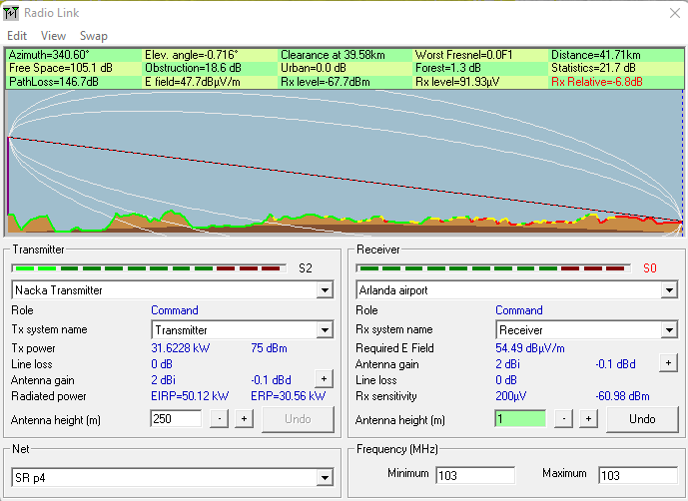

**Figure 15**: Radio link results for Nacka to Arlanda

**Single Polar radio coverage:**

From Nacka transmitter to Kista receiver,

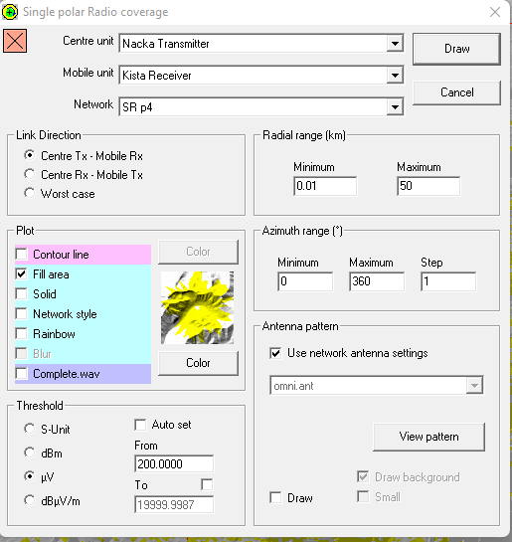

**Figure 16**: Single polar radio coverage for Nacka to Kista

From Nacka transmitter to Arlanda airport,

**Figure 17**: Single polar radio coverage for Nacka to Arlanda